National College of Ireland

Higher Diploma in Science in Computing

Web Design and Client Side Scripting

Lecturer:

Eugene McLaughlin

|  |  |
| --- | --- |
| **STUDENT NAME** | **STUDENT ID** |
| **Esmeralda Cristal Humerez Romero** | **X23150017** |
| **Hyewon Kim** | **X23177250** |
| **Muhammad Syamil Bin Rizaudin** | **x23104660** |
| **Ricardo Abraham Cruz Liga** | **x23127856** |

**“Mofu Mofu Nyan - Website”**

[**www.mofu**](http://www.mofu)**......**

|  |  |
| --- | --- |
| **Table of contents:** | **P.3** |
| **1.** Executive summary. | **P. 7** |
| **1.1.** D........... | **P. 7** |
| **1.2.** D............ | **P. 8** |
| **2.** Project work. | **P. 9** |
| **2.1.** D........ | **P. 9** |
| **2.2.** D....... | **P. 9** |
| **2.3.** R............... | **P. 10** |
| **2.4.** R............ | **P. 11** |
| **3.** Design process. | **P. 12** |
| **3.1.** C.................. | **P. 12** |
| **3.2.** C.................. | **P. 14** |
| **3.3.** L................... | **P. 19** |
| **3.4.** E................ | **P. 19** |
| **4.** Testing and responsiveness. | **P. 27** |
| **4.1.** D..... | **P. 27** |
| **4.2.** C......... | **P. 29** |
| **4.3.** C....... | **P. 30** |
| **Conclusion.** | **P. 46** |
| **References.** | **P. 48** |

**1. Executive summary**

Nowadays we have many coffee shops, for that matter we decided to innovate and create a new concept relating a good coffee experience and the Asian culture based on maid cafe.

In addition of that, to give a great service, we have developed a website that can present to the user all the amenities and what type of environment is going to experience with his visit.

Websites are the first contact with clients if they have never been there before, for that reason we need to make it easy and accessible in multiple devices so our site can be reach as much as possible.

The team has agreed into the idea of maid cafe, so we can have different types of pages and we can code with all the knowledge that we had learned during the course.

The first step after choosing a general idea, was to visit some websites that already exist and we can use them as a referent.

**Websites that we consulted:**

* At-home cafe “ [秋葉原・大阪のメイドカフェなら【あっとほぉーむカフェ】 | 400人のメイドがお出迎え！ (cafe-athome.com)](https://www.cafe-athome.com/)”: The idea of having an Asian coffee shop with drinks, pastries and other things are well represented in this website, making us to use this site as an example to develop the wireframes and to have a general picture of what we wanted to develop.
* Maidreamin “[メイドカフェ・メイド喫茶【めいどりーみん】｜ 秋葉原、大阪、名古屋、小倉、他全世界20店舗展開中! (maidreamin.com)](https://maidreamin.com/multilp/): This website gave us the idea of what type of food and beverage are serving in a made cafe and how the menu looks like.
* AkihabaraAkiba Absolute ” [Akihabara's Maid Cafe|Akiba Absolute Realm|Kawaii Maid Cafe & Bar (akibazettai.com)](https://akibazettai.com/): With this website we got the principle idea of the page related to maids, how they dress and the costume that makes a maid cafe unique and different from other coffee shop.

**Project work**

After we saw different websites, we agreed in split the pages so everybody will develop two pages and then we can link them.

After we discussed the general idea, and chosen which pages are we going to create, we created the eight wireframes so we can have a main image of how is going to work and the relation between all the pages, so we can have order, and a well-structured website.

**Design Process**

WIREFRAME – Landing Page (Home Page):

WIREFRAME – Maids:

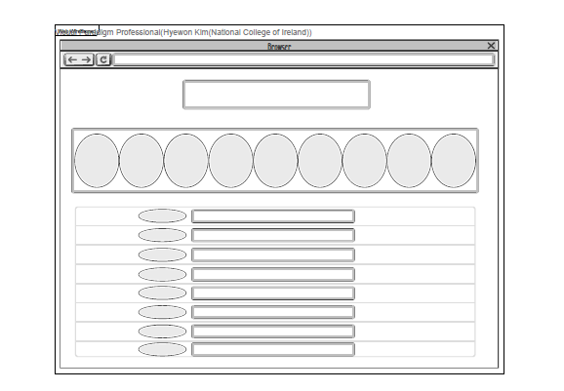

In the maid list, it displays pictures of maids with explanations of their jobs. Using a carousel motion, the pictures come to life on a display stand. I've set it in an infinite routine, and each of the ten maids has a different job concept, making it more entertaining for customers. I've added some emojis next to their names and bios to make it look cuter. The pictures are created using my face with various AI filters. I've distinguished the intervals between each maid list box. Additionally, I've added a reservation button in the middle of the pages, which is linked and can be used to navigate to the reservation page.

WIREFRAME – Access (Where to Find Us):

The wireframe under review depicts a navbar that links all the pages and the minigame, also we have the opening hours of the coffee shop, then there is a image, under the image there is a chart that represents the days and schedules.

The next part of the image represents the location and a map that will point the exact location, so the user can find the place and interact with the map.

Finally, there is a container that has images of the place to give an idea of how it looks the place.

WIREFRAME – Prices and Packages:

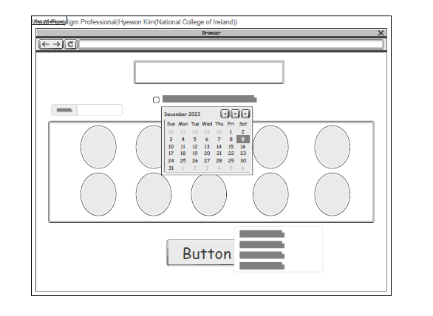WIREFRAME – Reservations:

I’ve created a reservation page where users can select the desired date and maid name to make a reservation. When a maid is chosen, their name will be displayed in the top-left corner. If the user presses the confirm button without selecting a date, an alert window will prompt them to choose a maid. After selecting the date, time, and maid, pressing the decision button will trigger an alert window to confirm the reservation details. Upon pressing ‘OK’, the page transitions to a window where the user can verify the price.

양식의 맨 위

WIREFRAME – Menu:

WIREFRAME – Rule Book:

This wireframe represents the Rule Book. In this page there is a title, secondly there is a list:

* Prohibited.
* Dress appropriately.
* Seating.
* Ordering process.
* Respect other costumers.
* Have Fun.

Finally there is a button created with java script that will display the message “Thanks for accepting the rule book. Enjoy!!!”.

WIREFRAME – Minigame:

WIREFRAME – Sitemap

**HTML, CSS, and Java Script**

Esmeralda Cristal Humerez Romero

Hyewon Kim

<HTML>

Creating a basic framework and delineated areas for text and photos. Additionally, to accommodate descriptions of maids, I detailed the sections using Div class codes. With the use of image files and paragraphs, I was able to convey explanations about each maid.

<CSS>

I blended pink and purple colors appropriately for the maid café theme. To maintain a cohesive background, we decided to use the same backdrop as our team members. For the maid photos, I trimmed them and added effects to enhance their visual appeal. Additionally, I incorporated a carousel-like infinite scrolling feature for a dynamic viewing experience. On the reservation page, I added a moving effect to the maid photos, adding an extra layer of fun.

<JavaScript>

I configured the functionality to transition from the Maid List to the Reservation page. On the Reservation page, users can select their desired maid and decide on the date and time. I implemented a ‘Select’ feature to display the maid’s name when chosen. To ensure users select a maid before proceeding, I created an alert prompting them to choose a maid if none is selected. I defined the Reservation function to confirm the selection enabling users to move to the price page after confirmation.

Muhammad Syamil Bin Rizaudin

Ricardo Abraham Cruz Liga

The HTML code is designed to create a webpage that provides information about the location and opening hours of "Mofu-Mofu-Nyan." The code includes various elements such as headings, images, tables, a map, a container with pictures and a rulebook with a button that displays a message by using an external java script.

* HTML Structure: The code follows the standard HTML structure, starting with the <!DOCTYPE html> declaration and containing the <html>, <head>, and <body> tags.
* CSS Styling: The code includes a link to an external CSS file to apply styles to the webpage. The CSS file contains rules that define the appearance of elements such as headings, images, navbar, style, size, font, and position.
* Meta Tags: The <meta> tags in the <head> section provide additional information about the webpage. These tags include the page title, description, keywords, author, viewport settings, and compatibility with Internet Explorer.
* Content: The code includes various elements to display such as headings, images, a table, a map, and a video background.
* JavaScript: The code includes a reference to an external JavaScript, this file add interactivity and functionality to the webpage like create a container where the picture slides are changing automatically every two seconds and displaying an alert when the user press the button.

**Testing and responsiveness.**

**Responsiveness**

**Add bootstrap explanations**

**Validation**

For the validation we did a satisfactory pre-deployment, the only thing is that we fixed some errors that can give a better quality to the website.

For this part, we have used the web site W3C Markup Validation Service <https://validator.w3.org/>.

In this site we validated the HTML and the CSS.

Add picture of the validation process

**Deployment**

Deployment of the website on the cloud service GearHost® was conducted according to the instructions provided on Moodle via FTP transfer of files into the root directory of the server using the programme WinSCP.

The final website within the functioning folder structure was deployed without problems and can be found at URL: <http://ncirunningclub.gear.host>

The online document validates for HTML5 and CSS3 standards without errors.

**Conclusion**

The final result represents…………….

# **References**

Angappa, A. (no date) *Software quality management: A comprehensive guide with examples and best practices*, *Software Quality Management: A Comprehensive Guide With Examples and Best Practices*. Available at: https://www.lambdatest.com/learning-hub/quality-management (Accessed: 15 November 2023).

Aston, B. (2023) *9 of the most popular project management methodologies made simple*, *9 Of The Most Popular Project Management Methodologies Made Simple*. Available at: https://thedigitalprojectmanager.com/projects/pm-methodology/project-management-methodologies-made-simple/ (Accessed: 16 November 2023).

Bernard, B. and Allen, H. (2014) *Object-Oriented Software Engineering Using UML, Patterns, and Java.* 3rd edn. England: Pearson.

James, M. (1992) *Principles of object-oriented analysis and design*, New Jersey: Prentice Hall.